
BULE HORA UNIVERSITY
COLLEGE OF INFORMATICS
DEPARTMENT OF SOFTWARE ENGINEERING
COURSE TITLE:-SOFTWARE ENGINEERING TOOLS AND PRACTICE
COURSE CODE:-SEng5331
PROJECT TITLE:-EMPLOYERS MANAGEMENT SYSTEM
Done by
Name ID
- Bilisuma Tesfaye ………………………………0571/16
- Ebisa Indalu……………………………………0613/16
- Lemesa Bekele…………………………………0620/16
- Jiregna Meseret………………………………..0378/16
- Abera Asefa……………………………………0601/16

Submitted to Mr.Getahun F.
Submission date 30/03/2018 Ec
Bule Hora, Oromia, Ethiopia

Table Contents page

Introduction 1
1.1 Project Background 1
1.2 Objectives 1
1.3 Scope 2
2.Domain Analysis 2
2.1 Problem Domain 2
2.2 Stakeholders & Actors 2
2.3 Business Processes 3
2.4 Domain Entities 3
3.System Requirements 4
3.1 Functional Requirements 4
3.2 Non-Functional Requirements 4
3.3 User Stories 5
4. Design Diagrams 5
4.1 Class Diagram 5
4.2 Sequence Diagram – Check-In/Out 7
5.Some concept About Github 8
What is Git? 8
5.1 Main Concepts of GitHub 9
5.2 GitHub Actions 10
5.3 README File 10
5.3.1 Broader Importance of GitHub 10
Summary 11

Introduction

1.1 Project Background
This SRS defines the functional and non-functional requirements of the Employee Management System (EMS), a web-based solution designed to automate employee attendance tracking using shift-based QR codes. The system eliminates manual verification, reduces time wastage (15–20 minutes daily per employee), and prevents payroll losses caused by inaccurate or manipulated attendance logs.

1.2 Objectives
General Objective
Develop a scalable web system for accurate employee time tracking and attendance management.
Specific Objectives
- Implement QR-based check-in and check-out during active shifts.
- Automatically calculate daily working hours and overtime (>8 hours/day).
- Generate attendance reports (daily, weekly, monthly).
- Provide supervisor approval workflows.
- Ensure robust data security and system scalability.

1.3 Scope
Included
- QR attendance (check-in/check-out)
- Automatic time and overtime calculation
- Attendance reporting
- User management (Admin, Supervisor, Employee)
Excluded
- Biometric integration
- GPS tracking
- Direct payroll computation

2.Domain Analysis

2.1 Problem Domain
Traditional manual attendance processes are prone to late logging, proxy punching, and hour disputes, creating operational and payroll inefficiencies. EMS targets medium-to-large organizations running multiple daily shifts requiring precise time tracking for compliance and payroll accuracy.

2.2 Stakeholders & Actors
Actor,  Employee | Role,  Scans QR to check in/out of shifts
Supervisor | Activates shifts monitors attendance approves hours
Admin | Manages departments employees system setup
HR/Payroll | Accesses aggregated reports for salary processing

2.3 Business Processes
Process Flow
- Employee Onboarding
- Department Assignment
- Shift Scheduling
- Check-in (QR)
- Work Period
- Check-out (QR)
- Automatic Hour Calculation
- Supervisor Review/Approval
- Report Generation
Core Metrics
- Daily Hours = checkOutTime − checkInTime
- Overtime > 8 hours/day
- Late Arrival = checkInTime > shiftStart + 15 minutes
- Monthly Total Hours per Employee

2.4 Domain Entities
Entity | Description | Key Attributes
Employee | Staff member tracking attendance | employeeID, name, email, department
Department | Organizational unit | deptID, name, supervisor
Shift | Work period instance | shiftID, date, startTime, endTime
Attendance | Record of check-in/out | attendanceID, checkInTime, checkOutTime, workingHours, status

3.System Requirements

3.1 Functional Requirements
- FR1: Employee scans shift-specific QR to check in during active shift.
- FR2: System records check-in timestamp and prevents duplicate check-ins.
- FR3: Employee scans the same QR to check out; system calculates working hours.
- FR4: Supervisor opens/closes shifts and views real-time dashboard.
- FR5: Admin manages employees, departments, and shift templates.
- FR6: System generates/exportable reports (daily, weekly, monthly).
- FR7: Alerts for late arrivals and early departures.

3.2 Non-Functional Requirements
Category | Requirement
Performance | <2s QR scan response; support 1000+ concurrent users
Security | Role-based access; shift-specific QR expires after shift
Usability | Mobile-responsive UI; intuitive QR scanner
Reliability | 99.9% uptime; daily data backups
Scalability | Cloud-ready modular system architecture

3.3 User Stories
Employee
As an Employee, I want to scan QR on arrival so my check-in is logged automatically.
As an Employee, I want to view my working hours after check-out.
Supervisor
As a Supervisor, I want to see real-time shift attendance.
As a Supervisor, I want to approve overtime requests easily.

Design Diagrams

Class Diagram
The class diagram represents the core structure of the Employers Management System focused on attendance tracking during work shifts. It captures five main classes—Employee, Attendance, Shift, Department, and Supervisor—and their relationships in managing employee attendance data effectively.
Employee class:-stores employee information such as employeeID, name, email, and departmentID. Each employee can have multiple attendance records, reflecting their work activity over different shifts.
Attendance class:-contains detailed attendance info, including attendanceID, checkInTime, checkOutTime, workingHours, and status. Each attendance record corresponds to one employee and is linked to one specific work shift.
Shift class :-holds shift details like shiftID, date, startTime, and endTime. A shift has multiple attendance records representing all employees' attendance for that session.
Department class:-groups employees and organizes them within the company structure. It has the ability to add employees to the department, representing a one-to-many relationship where one department comprises many employees.
Supervisor class:-represents the managerial role overseeing departments and shifts. Supervisors are responsible for managing shifts and monitoring attendance within the departments they supervise.
The relationships use UML associations with multiplicities indicating “one-to-many” or “many-to-one” connections, reflecting real organizational structures. For example, one employee can have many attendance records, one shift can have many attendance records, and one department can employ many employees.
This diagram captures the foundational entities and their interactions required to manage employee attendance through check-ins/check-outs within defined shifts under supervisory oversight. It forms the basis for implementing the system’s business logic and database schema.
Each class and relationship here supports an efficient design for managing attendance data while maintaining clarity of roles and data flow within the Employers Management System.
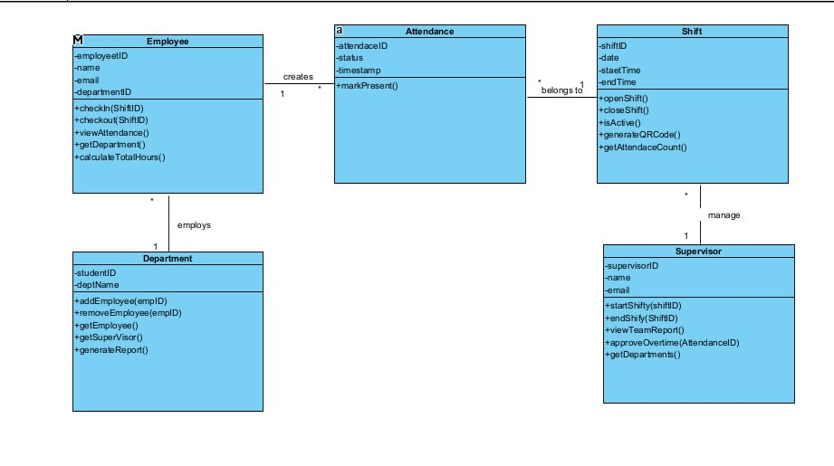

Sequence Diagram – Check-In/Out
Employee → QR Scanner → System → Database → Supervisor

1. Employee scans QR
2. System validates QR and shift status
3. System records check-in timestamp
4. During check-out, system calculates hours
5. System saves and displays working hours
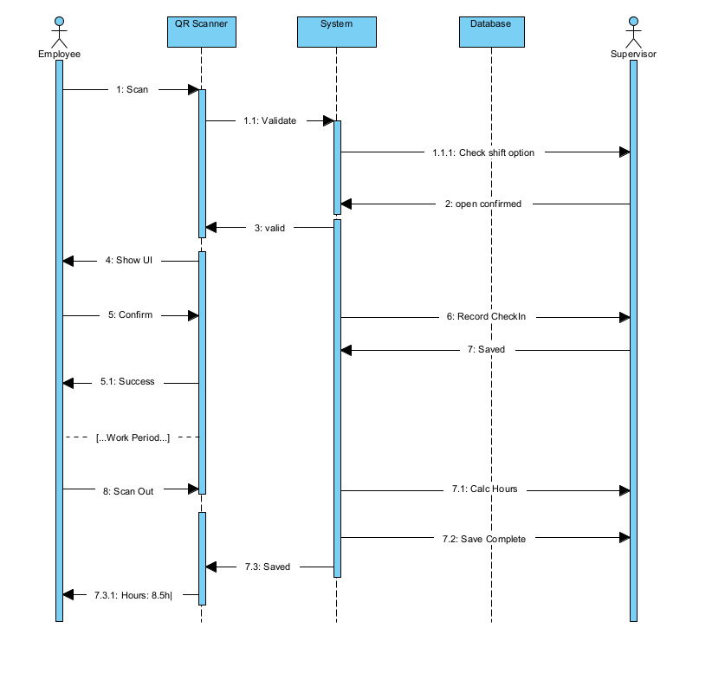

5.Some concept About Github
GitHub is a comprehensive platform centered on Git, designed to facilitate collaborative software development by managing code, tracking changes, and supporting version control. Exploring its concepts deeply highlights how it empowers developers and teams to work efficiently.

What is Git?
Git is a distributed version control system created by Linus Torvalds to manage source code history. Unlike centralized systems, Git allows every developer to have a full copy of the project history locally. This enables offline work, faster operations, and reliable backups. Git tracks changes at a granular level, identifying exactly who made which change and when. This feature prevents data loss and allows multiple developers to work concurrently without overwriting each other’s contributions.

5.1 Main Concepts of GitHub
- Repository (Repo):-This is the fundamental space where a project’s code, documentation, commit history, and branches live. Repositories can be public (open for everyone to see and contribute) or private (restricted access). The repo acts as the project’s central hub.
- Branch:-Branches enable parallel development by creating independent lines of work within the same repository. For example, developers can create feature branches to implement new functionality or fix bugs without disturbing the main branch’s stable codebase. Later, these branches can be merged after review.
- Commit:-A commit is a snapshot of changes made to the project files. It includes metadata like who made the change, what was altered, and an explanatory message. Commits form the history of a project and help track progress or revert to earlier versions when necessary.
- Pull Request (PR):-Pull requests enable collaboration by proposing code changes from one branch into another, typically into the main branch. Team members review these changes, chat about them, test the code, and decide whether to merge the updates. This helps maintain code quality and peer accountability.
- Merge:-Merging integrates changes from one branch into another, usually after a successful PR review. It combines different lines of development into a unified codebase.
- Fork:-Forking creates your own copy of someone else’s repository. It’s essential for contributing to open-source projects because it lets you experiment and modify code independently before suggesting improvements via PR.
- Issues:-Issues act as a communication platform within the repository to report bugs, request features, ask questions, or track tasks. They improve project transparency and team coordination.

5.2 GitHub Actions
GitHub Actions automate workflows triggered by events like code commits or pull requests. They can run tests, deploy applications, or execute any scripts, reducing manual repetitive tasks and enhancing Continuous Integration/Continuous Deployment (CI/CD) pipelines.

5.3 README File
The README file is the entry point in any repository and provides crucial context such as the project’s purpose, installation instructions, usage guidelines, contributor info, and licensing. It helps new users quickly understand and start using the project.

5.3.1 Broader Importance of GitHub
- Collaboration: GitHub supports multiple developers working together seamlessly, enabling parallel development without code conflicts.
- Version Control: It offers a detailed history of all changes, allowing users to undo errors, restore past versions, and compare changes effectively.
- Open Source Community: GitHub hosts millions of open-source projects, encouraging global collaboration that improves software quality and innovation.
- Developer Portfolios: GitHub acts as a professional showcase where developers display their projects and skills, influencing job opportunities.
- Cloud Storage: Repositories are stored online, providing secure access to code from anywhere and safeguarding against data loss.
Overall, GitHub integrates essential tools for modern software development — combining powerful version control with collaboration, automation, and community engagement. Mastering GitHub enables developers and students to manage projects efficiently, contribute to open-source, and build strong, visible coding portfolios.

Summary
The document thoroughly defines an EMS that uses QR codes for accurate attendance tracking, replacing flawed manual systems. It details system objectives, scope, requirements, domain entities, actor roles, workflow, class/sequence diagrams, and includes an educational section on Git and GitHub to support development. The system focuses on reliability, security, scalability, and usability, offering a modern solution for organizations managing multiple shifts.

References
https://www.eventbrite.com/blog/event-management-software/

